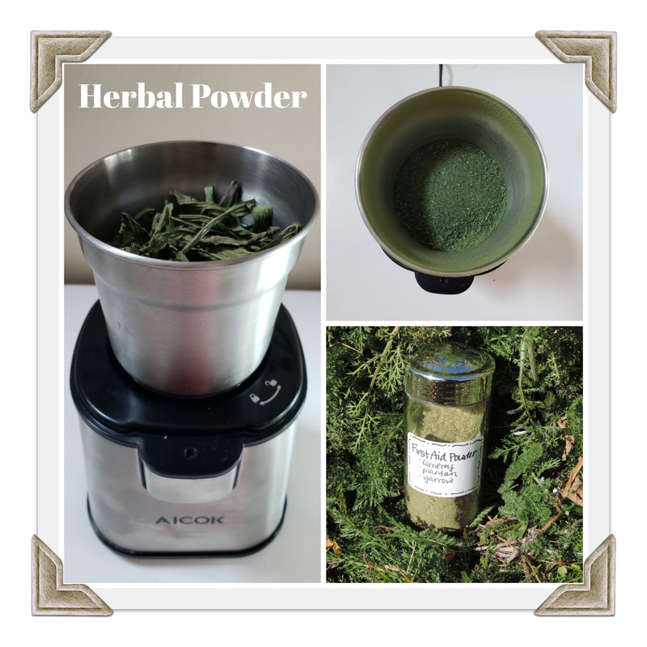
After drying your herbs, place them in a coffee grinder or high-powered blender to grind into a powder. They will break down faster after powdering so I usually powder right before using. These can be used to make herbal capsules, pills, poultices, pastes, gruel, and sprinkles.

Sprinkle: As a sprinkle for cooking, just crush to a coarse powder as you would find at the grocery store. These are fun to make special blends and combinations for all sorts of use in the kitchen. Store in old spice jars and used to incorporate into meals. (The Herbal Kitchen by Kami McBride has some great recipes for sprinkles and there are few recipes spread throughout this book). Sprinkles can also be used over cuts and wounds as with the First Aid Powder (recipe in Lesson 11).

Gruel: Place powdered herbs in a bowl and add enough water, honey, pure maple, or other liquid to form a stew like consistency. I like to add filler ingredients as well such as psyllium seed or flax seed if an herb is too strong.

Paste: A paste is made just like a gruel except your consistency is going to be thicker. These can be applied as a poultice.

Liquid Herbs: My body does not like herbal capsules, so I came up with a quick, instant way to take herbs that I haven’t made into tinctures yet. I get a shot glass, add the amount of powdered herbs I’m taking (a capsule generally has 1 teaspoon of herb packed in it). Add water to fill the glass, stir well, chug it down.

