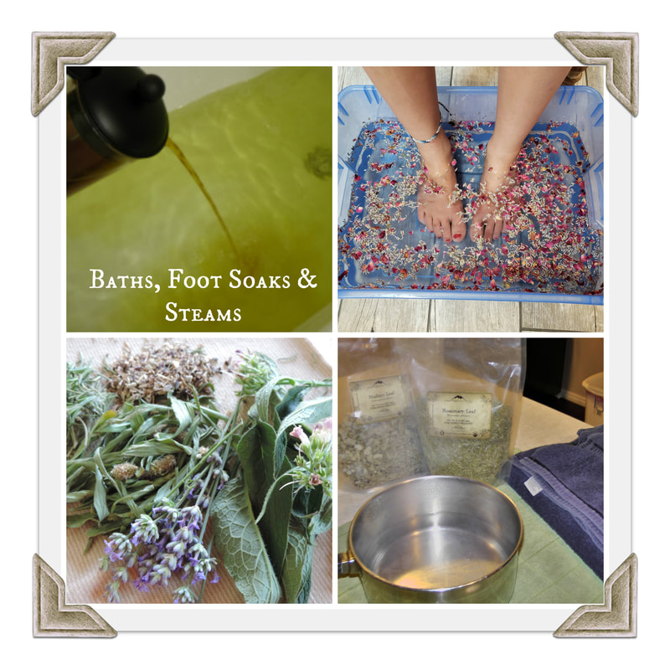
An herbal bath is like immersing yourself into a big pot of tea. The warm water opens the pores of the skin allowing it to absorb the medicinal properties of the herb, while also eliminating toxins. This is one of the easiest ways to administer herbs to children. Here are a couple ways to prepare an herbal bath:

Herbal Infusion: This is the most effective method. Make a very strong batch of herbal tea, strain and then pour the tea into the bath. A strong batch could be one-part herb to two parts water.

Tea Bag Method: Fill a muslin bag with herbs and tie up. Hang over the faucet as the hot water fills the bath, then throw the whole bag into the bath water while bathing. Alternatively, you can also place the herbs in a washcloth, handkerchief, or nylon stocking and tie up the ends.

Loose Herbs: Throw your herbs directly into the bath water, the heat from the water will extract the properties into your bath water. This is messy and you will need to filter out the herbs before draining your bath water.

Foot Soak: A foot soak is more concentrated than a bath and sometimes easier to administer. The feet have the largest pores of the body, therefore absorbing the herb more quickly into the blood stream. Just fill a basin, bucket, or tub with water as hot as you can stand. Use the same methods as the bath.

Steam Inhalation: Wonderful for opening the sinus and respiratory systems. It is also used for deep cleansing the pores of the skin. Heat a large pot of water until it is steaming. Add a handful of herbs, good ones for sinus are mullein, peppermint, lavender, thyme, and rosemary. Set the pot on a table, be careful, it is hot. Lean head over the pot and cover with a towel. Inhale the steam for 5-10 minutes or for as long as you feel.

