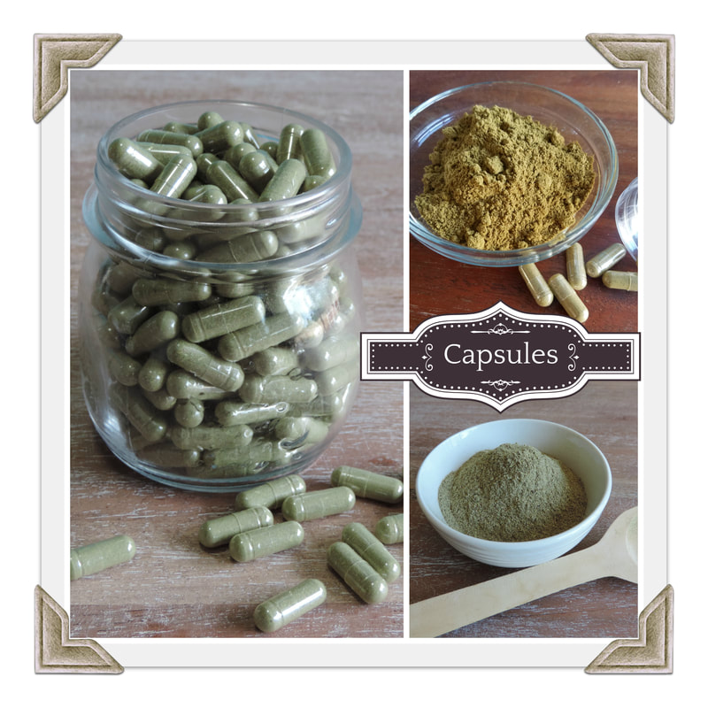

Capsules are a good way to go for those who cannot handle the taste of herbs through the other methods mentioned above. Some herbs have a very strong, even unpleasant taste and these would be great for encapsulating. They are also good for those who like the convenience of popping a pill and they are easy to make. You will need to purchase a capsule machine and some glycerine capsules. There are two common sizes: 00 is the most common and 0 is a little smaller for those that have a hard time swallowing the larger capsules.

Capsule How To: Grind your herbs of choice in a coffee grinder or high-powered blender after they have been dried thoroughly. You can also purchase powdered herbs. Place the capsules in the capsule machine and fill with the powdered herbs. Join the two sides of the capsule machine together and press down firmly, then pop out. The capsule machine has detailed instructions.
Capsule Dosage
These dosages are based on the size 00 capsules. Adjust as needed for the smaller 0 size. Acute conditions 1 or 2 herbal capsules every 2 hours, for a total of 8 capsules a day.
Chronic conditions 2-3 capsules 2 or 3 times a day for a total of up to 6 capsules a day.
These are just guidelines, go with what the body needs.

